**Data Logger of Temperature, Humidity, Barometric Pressure with LoRa Module 915 MHz Using Two Array Rectangular Microstrip Antenna on Elevation**

**M. Alif Ali Al-Barsyah1, Mochammad Taufik2, Koesmarijanto3\***

1Digital Telecommunication Network Study Program, Department of Electrical Engineering, State Polytechnic of Malang, 65141, Indonesia.

2,3Telecommunication Engineering Study Program, Department of Electrical Engineering, State Polytechnic of Malang, 65141, Indonesia.

[1alifalial.barsyah@gmail.com](mailto:1saepulrahmat@pnc.ac.id), [2moch.taufik@polinema.ac.id](mailto:2hendipurnata@pnc.ac.id), [3](mailto:3author3@polinema.ac.id)koesmarijanto@polinema.ac.id

***Abstract*— LoRa has become one of the most efficient solutions in implementing the Internet of Things (IoT) due to its essential features, such as cost-effectiveness and low-power wireless platform. The microstrip antenna is a unique type of antenna known for its lightweight, small size, ease of fabrication, and the ability to conform to various surfaces. Compared to other types of antennas, it has a smaller physical footprint. In terms of radiation pattern measurement, the microstrip antenna exhibits bidirectional characteristics, meaning it focuses the signal radiation in two specific directions. The objective of this research is to examine and evaluate how the communication quality between LoRa modules is affected by using a bidirectional microstrip antenna. This is compared to the built-in LoRa antenna, which has an omnidirectional radiation pattern, distributing signals evenly in all directions. The study aims to analyze the impact of the bidirectional microstrip antenna on the performance and communication range within the LoRa network. Based on the performance comparison graph of Received Signal Strength Indicator (RSSI) for each antenna – the built-in antenna, the microstrip antenna, and the microstrip antenna at a 90° tilt – it is evident that the microstrip antenna at a 90° tilt exhibits the highest RSSI value, while the built-in antenna shows the lowest RSSI value.**

***Keywords*— *Antenna, Data Logger, LoRa, Microstrip, Rectangular.***

1. INTRODUCTION

LoRa is a modulation technique based on spread spectrum, obtained from a technology called Chirp Spread Spectrum (CSS). LoRa has become one of the most effective solutions in the Internet of things (IoT) field as it serves some of its most significant features, such as low cost and low power wireless platforms. And solving several types of real-life problems such as pollution control, disaster prevention, energy management, natural resource reduction, and automation [1].

Microstrip antenna is an antenna that has a light mass, small dimensions, easy to manufacture, with conformal characteristics so that it can be placed on almost all types of surfaces and small in size compared to other types of antennas. [2]. The microstrip antenna has a bidirectional antenna radiation pattern [3].

This research proposes how to make a temperature, humidity and air pressure data logger with a 915 MHz Lora module using a two array rectangular patch microstrip antenna on elevation. This study aims to analyze how the quality of communication between Lora modules is if the antenna used has a bidirectional radiation pattern such as using a microstrip antenna considering that the built in Lora antenna has an omnidirectional radiation pattern.

Previous research contains research that has been conducted by other parties. In this section, a research abstract related to the author's research will be presented which will be used as a reference in this study.

In the thesis research conducted by Ahmad Supriyogo, et al in 2022 with the title "The Influence of Line Of Sight And Non Line Of Sight Conditions On Data Transmission Using Low Power Wide Area Network Technology" said that the LoRa RFM95W communication at LOS with hot and cold weather conditions resulted in a distance of 100 meters to 1000 meters. In RFM95W LoRa communication on N-LOS with hot and cold weather conditions it produces a distance of 100 meters to 500 meters. In LoRa performance with line of sight (LOS) communication in hot and cold weather conditions, the farther the distance that can be covered, the lower the RSSI and SNR results and the higher the ToA value, which means that the transmission time becomes longer. In LoRa performance with non-line of sight (N-LOS) communication with hot and cold weather conditions, the farther the distance that can be reached, the RSSI results increase and affect changes in SNR, and the ToA results increase which means the transmission time becomes longer [4].

Then research on LoRa performance was also researched by Hendro F. J. Lami and Stephanie I. Pella in 2022 entitled "Analysis of the Impact of Interference on Network Signal Quality Long Range Frequency 920 Mhz-923 Mhz(As2)". ToA testing shows that the greater the bandwidth the smaller the ToA value, while changes do not affect ToA. RSSI testing shows that changes in distance affect the RSSI value more than changes in bandwidth. the presence of interference signal has no significant effect on the RSSI value. SNR testing shows that the greater the bandwidth the smaller the SNR and significantly when interference occurs [5].

In research conducted by Zilliah Mankusa, et al in 2021 entitled "Design and Realization of Broadband Circular Microstrip Patch Antennas for Lora-Based Receivers and Ads-B on the Kubus 2u Satellite," said that the antenna was designed to use a working frequency of 1018 MHz with a bandwidth of 167 MHz. The designed antenna has an omnidirectional radiation pattern and circular polarization. microstrip antenna with multilayer substrate method, ring slot, partial groundplane, truncatted. got a bandwidth of 168.38 MHz for simulation and for measurements got a bandwidth of 372 MHz. The design results show that the antenna meets the criteria for a wideband antenna and meets the specifications for a nanosatellite antenna [6].

The explanation above is one of the references in this study entitled "Air Humidity and Air Pressure Data Logger With Lora 915 MHz Module Using Two-Element Rectangular Patch Microstrip Antenna At Altitude" using the LoRa [7][8] RFM 95W module as a data sending and receiving medium, microstrip antenna [9][10] as a transmission amplifier in the LoRa module, NodeMCU ESP 32 [11] to process data and measure the performance of the LoRa RFM 95W module and DHT 11 sensor [12[ to measure air humidity [13][14].

1. METHOD
2. *Diagram Block*

The block diagram of “Temperature, Air Humidity and Barometric Pressure Data Logger With Lora 915 MHz Module Using Two-Element Rectangular Patch Microstrip Antenna [15] At Altitude” is as follows Fig.1.

Based on the system Figure 1, it can be explained into several parts as follows:

Transmitter:

1. Rectangular antenna functions as the transmission antenna of the RFM95W module.
2. The RFM95W LoRa module functions to send data to the receiving side.
3. ESP 32 functions as a data processor and instructs the lora module to send data to the receiving side.
4. The DHT 11 sensor functions as a sensor to measure temperature and air humidity.
5. 5.9v battery works as a power supply when the sender is in the air.
6. Data is sent on a frequency of 915 MHz.

Receiver:

1. Rectangular antenna functions as a receiver module RFM95W.
2. The RFM95W LoRa module functions to receive data from the sender side.
3. ESP 32 functions as a data processor and instructs the Lora module to receive data to the receiving side.
4. Data is received in the 915 MHz frequency
5. Data Logger’s App is used for monitoring and receiving results.

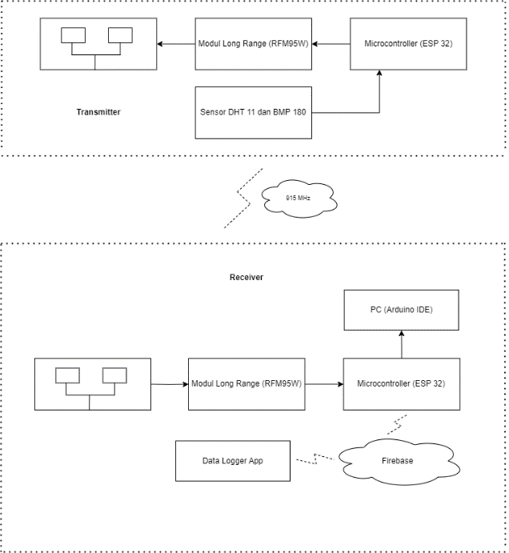

Figure 1. Block Diagram

1. *Microstrip Antenna Design Calculation*

Perform antenna dimension calculations in the form of calculating using basic antenna formulas to obtain results in the form of parameters on the microstrip antenna and the expected antenna shape. Microstrip antennas have several physical parameters, including Patch Width, Patch Length, and wavelength.

The equation used to calculate the wavelength of the antenna is the following equation:

1. Center Frequency

$fr= 915 MHz$

1. Wavelength

$λ=327 mm$

1. Width and Length Patch

$W= 98 mm, L= 77.2 mm$

1. Impedance of Radiating Elements

$Z_{A}=325 Ω$

1. Radiation Element Transmission Line Width

$W_{ZA}=1 mm$

1. ¼ Transformator to 100 Transmission Line

$Z_{T}= 180 Ω$

1. ¼ Transformator Transmission Width

$W_{ZT}=1.5 mm$

1. Supply Line Impedance

$Z_{2}= 50 Ω$

1. Transmission Width

$W_{Z1}=2.5 mm$

1. Supply Transmission Width

$W_{Z2}=5.1 mm$

Antenna Planning for "Air Humidity and Air Pressure Data Logger With Lora 915 MHz Module Using Two-Element Rectangular Patch Microstrip Antenna At Altitude" can be seen in Figure 2.

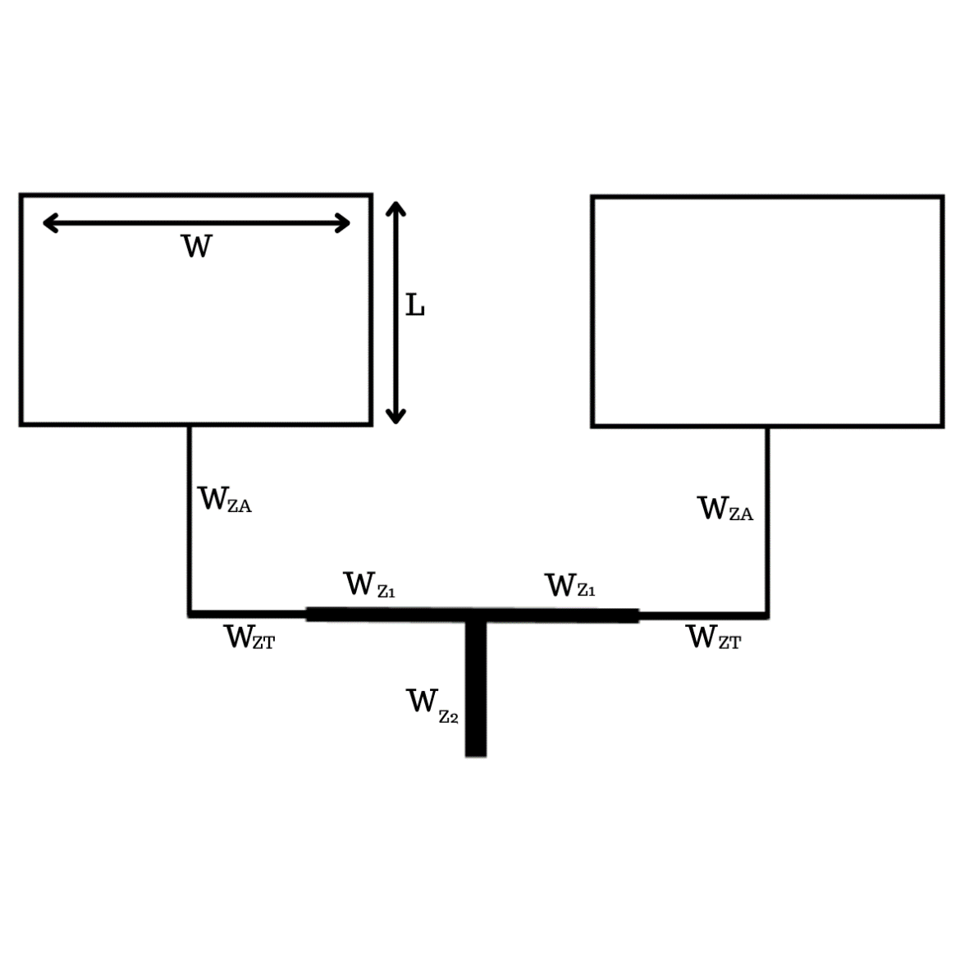

Figure 2. Microstrip Design

1. *Schematic Diagram*

Transmitter Schematic Diagram can be seen in Figure 3.

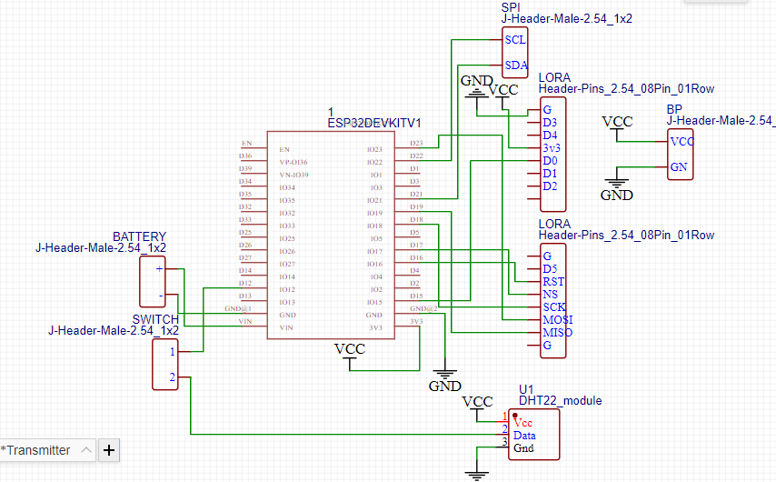

Figure 3. Transmitter Schematic Diagram

Receiver Schematic Diagram can be seen in Figure 4.

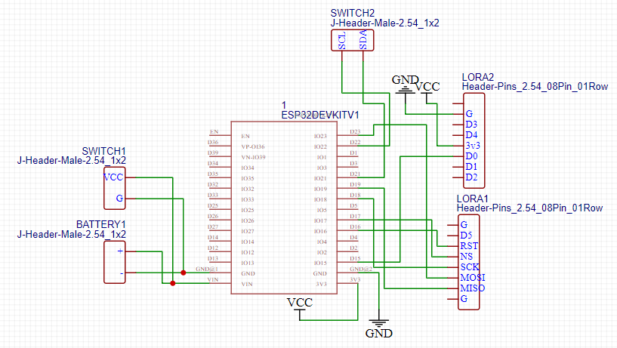

Figure 4. Receiver Schematic Diagram

1. RESULTS AND DISCUSSION

The results and discussion chapter is a chapter that contains the results and discussion of the implementation of the design planning that has been done in the research methods chapter. This chapter will explain the implementation of mechanical project view and several parameter testing.

Figure 6, 7, and 8 are an implementation of a mechanical design consisting of a front view and inside view.

* 1. *Implementation of Mechanical Design*

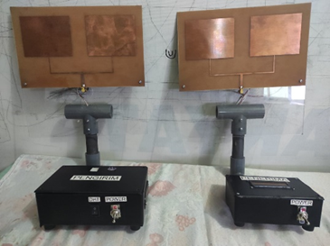

Figure 5. Project Front View

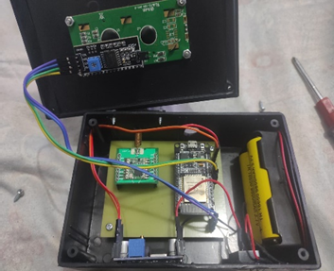

Figure 6. Receiver Inside View

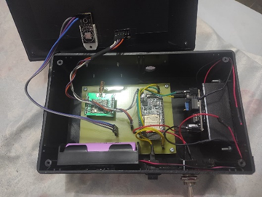

Figure 7. Transmitter Inside View

* 1. *Antenna Standart Parameter Testing*

The purpose of this test is to find out whether an antenna can be said to meet the standard if it meets the requirements of RL <-10 dB, VSWR <2, impedance of 50 Ω, gain and radiation pattern. Therefore, it is necessary to test the antenna that has been made can be seen in Figure 8, 9, and 10.

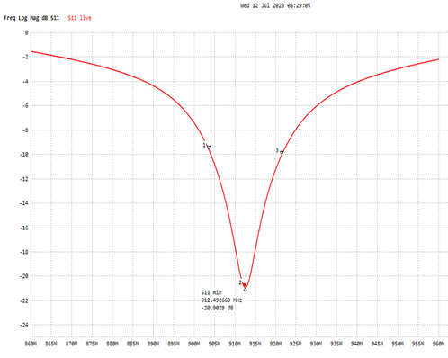

Figure 8. Return Loss Graph

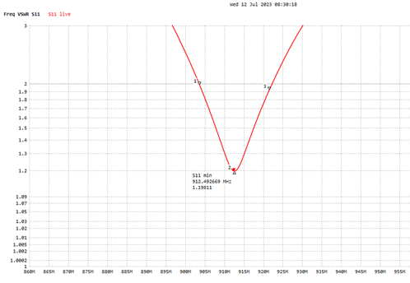

Figure 9. VSWR Graph

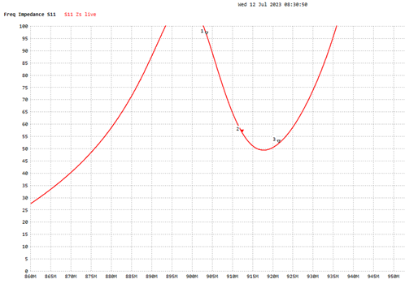

Figure 10. Impedance Graph

The resonant frequency is located at a frequency of 912 MHz with a return loss level value = -20.90 dB, a VSWR value of 1.198, and an impedance value of 56.60 Ω. which is still included in the working frequency which lies between 902 – 928 MHz can be seen in Table I.

Table I

Results Of Rectangular Microsip AUT Gain Measurements

|  |  |  |  |
| --- | --- | --- | --- |
| Frekuensi (MHz) | Level Terima | | Gain (dBi) |
|  | Ant. Ref | Ant. Uji |  |
| 890 | -51.3 | -52.4 | 1.4 |
| 895 | -57.5 | -52 | 8 |
| 900 | -58 | -49.5 | 11 |
| 905 | -60.6 | -49.7 | 13.4 |
| 910 | -60.6 | -50.9 | 12.2 |
| 915 | -51.7 | -48.4 | 5.8 |
| 920 | -50.4 | -47.7 | 5.2 |
| 925 | -49.8 | -47 | 5.3 |
| 930 | -52.7 | -49.6 | 5.6 |
| **Average (dBi)** | | | **7.54** |

Calculation of the gain on the antenna under test which can use the equation:

$Gain =LevelAUT-Levelref+2.51 dB$……………………….(1)

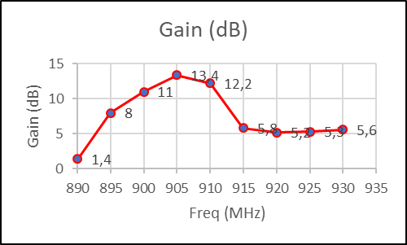

Figure 11. Gain Graph

Based on the Fig 11 and Table II, the highest gain value is located at a frequency of 905 MHz with a level of 13.4 dBi, for an average frequency range of 860-930 MHz, which is 7.54 dBi.

Table II

Measurement Results Of Rectangular Microstrip Radiation Patterns

| Angle ( $°)$ | Power Level (dBm) | Normalisation |
| --- | --- | --- |
| 0° | -47.4 | 0 |
| 10° | -47.7 | -0.3 |
| 20° | -48.6 | -1.2 |
| 30° | -49.5 | -2.1 |
| 40° | -52 | -4.6 |
| 50° | -53 | -5.6 |
| 60° | -53.8 | -6.4 |
| 70° | -54.5 | -7.1 |
| 80° | -54.6 | -7.2 |
| 90° | -54.9 | -7.5 |
| 100° | -55.6 | -8.2 |
| 110° | -56.1 | -8.7 |
| 120° | -59.2 | -11.8 |
| 130° | -67.2 | -19.8 |
| 140° | -70.5 | -23.1 |
| 150° | -63.1 | -15.7 |
| 160° | -61.8 | -14.4 |
| 170° | -63.1 | -15.7 |
| 180° | -64.6 | -17.2 |
| 190° | -63.7 | -16.3 |
| 200° | -60.1 | -12.7 |
| 210° | -59 | -11.6 |
| 220° | -61.6 | -14.2 |
| 230° | -61 | -13.6 |
| 240° | -60 | -12.6 |
| 250° | -57.7 | -10.3 |
| 260° | -57.4 | -10 |
| 270° | -57.2 | -9.8 |
| 280° | -56.7 | -9.3 |
| 290° | -55.6 | -8.2 |
| 300° | -53.8 | -6.4 |
| 310° | -51.7 | -4.3 |
| 320° | -50.2 | -2.8 |
| 330° | -49.1 | -1.7 |
| 340° | -48.1 | -0.7 |
| 350° | -47.7 | -0/3 |

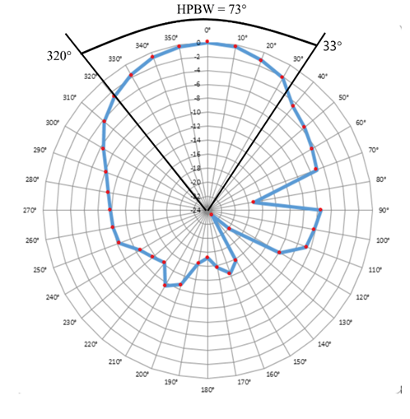

Figure 12. Radiation Pattern

Fig 12 shows normalize the results of radiation pattern measurements by means of the highest level results minus the lowest level. The purpose of normalization is to make it easier to plot and describe the shape of the antenna radiation pattern.

Determining the HPBW value by drawing the intersection line at the -3 dB level in the Figure 12 with the HPBW value based on the polar diagram can be seen Equation 2 and 3.

…………………………………….(2)

…………………………………………………………….(3)

* 1. *Antenna Implementation in Data Logger*

This sub-chapter presents the results of antenna implementation on a humidity and air pressure data logger with a 915 MHz Lora module using a two-element rectangular patch microstrip antenna on elevation.

Antenna implementation is done by taking the signal quality from the built-in antenna, and a square microstrip patch antenna. The data collection process is carried out using ESP 32 connected to LoRa, as shown in Fig 13 and 14.

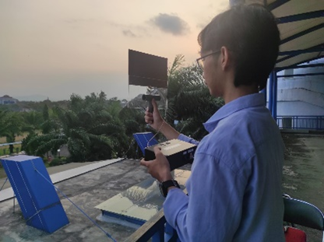

Figure 13. Antenna Implementation on Graha Polinema

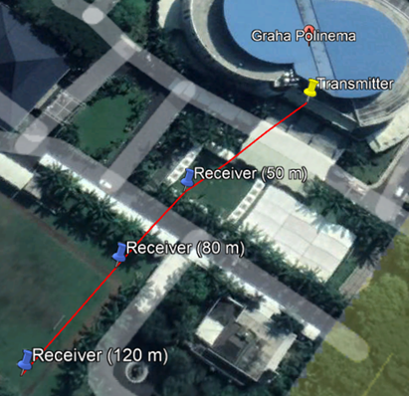

Figure 14. Implementation Map Plan

Table III

Signal Quality For Built-in Antenna

|  |  |  |  |
| --- | --- | --- | --- |
| ***Built-in*** | | **Mikrostrip (Miring 90 $°$)** | |
| Jarak (meter) | RSSI (dBm) | Jarak (meter) | RSSI (dBm) |
| 50 | -69 | 50 | -56 |
| 80 | -74 | 80 | -54 |
| 120 | -80 | 120 | -65 |

The test results in Table III, it is known that the RSSI results for the built-in antenna have the best value of -69 dBm at a distance of 50 meters and the worst value of -90 dBm at a distance of 120 meters.

From the test results in Table III it is known that the RSSI results on a microstrip patch rectangular two elements with a slope of 90° have the best value of -54 dBm at a distance of 80 meters and the worst value of -68 dBm at a distance of 120 meters.

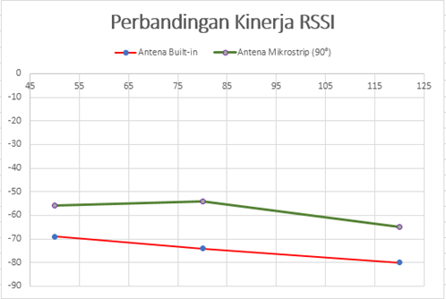

Figure 15. Comparation Graph For Signal Quality

1. CONCLUSION

Fabricated microstrip antenna is able to work at a frequency of 915 MHz. The frequency of 915 MHz has a bandwidth of 18 MHz, a VSWR value of 1.198, a return loss value of -20.90 dB and a gain of 5.8 dBi and a directional radiation pattern. Based on the results of the RSSI performance comparison chart for each antenna, namely the built-in antenna and microstrip antenna with a tilted position of 90°, it shows that the microstrip antenna with an inclined position of 90° has the best RSSI value, namely with a distance of 80 meters, the value is - 54 dBm and the built-in antenna has the worst RSSI value with a distance of 120 meters obtained -90 dBm.

REFERENCES

1. Islam, Rahabul, et al. (2022) "LoRa and server-based home automation using the internet of things (IoT)." Journal of King Saud University-Computer and Information Sciences 34, no. 6, pp: 3703-3712, January 2022.
2. Gultom, Yessi Kartini, Syah Alam, and Indra Surjati. (2022). "Microstip Antenna Reflection Coefficient with X Slot Addition Method for 5G Connection." Journal Of Informatics And Telecommunication Engineering 5, no. 2 pp: 532-544. January 2022.
3. Mujahidin, Irfan, dkk. (2015) "Rancang Bangun Rectifier Antenna Mikrostrip Ufo Pada Frekuensi Ultra Wideband (UWB) Sebagai Pemanen Energi Elektromagnetik." Jurnal Mahasiswa Teknik Elektro Universitas Brawijaya 3, no. 2 pp : 1-6.
4. S. Zhang, C. Zhu, J. K. O. Sin, and P. K. T. Mok, “A novel ultrathin elevated channel low-temperature poly-Si TFT,” IEEE Electron Device Lett., vol. 20, pp. 569–571, Nov. 1999.
5. J. Liang and J. Chen. “Joint Relay selection and Networkcoding for Error -Prone Two-Way Decode-and-Forward Relay Networks,” IEEE Transactions. Commununications, vol. 31, no. 3, pp. 476–488, July 2013.
6. T. Vu, P. Duhamel, and M. Renzo, “On the Diversity of Network-Coded Cooperation with Decode-and-Forward Relay Selection”, IEEE Trans. Wirel. Commun., vol. 14, no. 18, pp. 4369-4378, 2015.
7. A. A. Deshmukh and K. P. Ray, "Compact Broadband Slotted Rectangular Microstrip Antenna," in IEEE Antennas and Wireless Propagation Letters, vol. 8, pp. 1410-1413, 2009, doi: 10.1109/LAWP.2010.2040061.
8. C. Chen, "A Wideband Coplanar L-Probe-Fed Slot-Loaded Rectangular Filtering Microstrip Patch Antenna With High Selectivity," in IEEE Antennas and Wireless Propagation Letters, vol. 21, no. 6, pp. 1134-1138, June 2022, doi: 10.1109/LAWP.2022.3159230
9. Z. Tong, A. Stelzer and W. Menzel, "Improved Expressions for Calculating the Impedance of Differential Feed Rectangular Microstrip Patch Antennas," in IEEE Microwave and Wireless Components Letters, vol. 22, no. 9, pp. 441-443, Sept. 2012, doi: 10.1109/LMWC.2012.2212240.
10. D. Cao, Y. Li and J. Wang, "A Millimeter-Wave Spoof Surface Plasmon Polaritons-Fed Microstrip Patch Antenna Array," in IEEE Transactions on Antennas and Propagation, vol. 68, no. 9, pp. 6811-6815, Sept. 2020, doi: 10.1109/TAP.2020.2972696.
11. V. Sabino, D. B. Ferreira, O. M. C. Pereira-Filho and L. C. da Silva, "Analysis of Conical-Rectangular Microstrip Antennas," in IEEE Transactions on Antennas and Propagation, vol. 70, no. 6, pp. 4824-4829, June 2022, doi: 10.1109/TAP.2021.3137382.
12. A. Ghosh, S. Misra, V. Udutalapally and D. Das, "LoRaute: Routing Messages in Backhaul LoRa Networks for Underserved Regions," in IEEE Internet of Things Journal, vol. 10, no. 22, pp. 19964-19971, 15 Nov.15, 2023, doi: 10.1109/JIOT.2023.3281941.
13. D. Hunt, "LoRa Alliance Certification - Journal of ICT," in Journal of ICT Standardization, vol. 9, no. 1, pp. 13-20, 2021, doi: 10.13052/jicts2245-800X.912.
14. D. Croce, M. Gucciardo, S. Mangione, G. Santaromita and I. Tinnirello, "Impact of LoRa Imperfect Orthogonality: Analysis of Link-Level Performance," in IEEE Communications Letters, vol. 22, no. 4, pp. 796-799, April 2018, doi: 10.1109/LCOMM.2018.2797057.
15. T. K. Claudiani, koesmarijanto koesmarijanto, and hendro darmono, “Rancang Bangun Antena Semi Circular Dengan Teknik GDS (Defect Ground Structure) untuk Meningkatkan Bandwidth Antena Pada Aplikasi WIFI”, Jartel, vol. 11, no. 1, pp. 12-16, Mar. 2021.